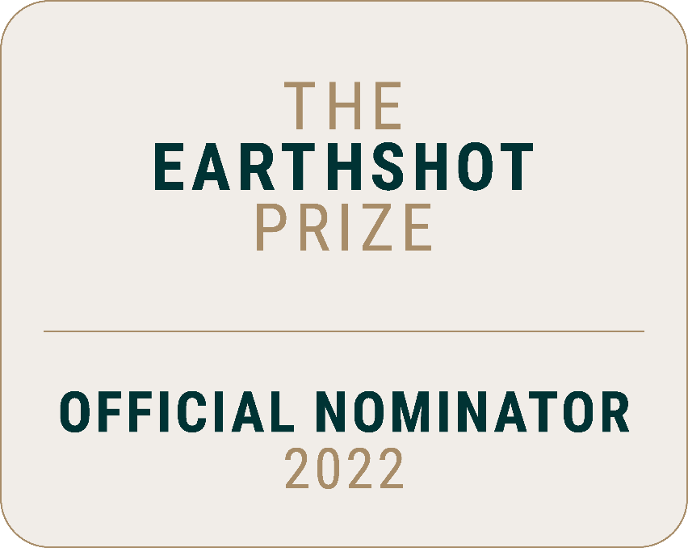

Nomination Form

Sections in the nomination form:
- Introduction
- Section 1: Key Information
- Section 2: Solution Details
- Section 3: Ambitions and Scaling

Section 1: Key Information
Please provide the following information on behalf of your Nominee.
- Solution Name
What is the name of the solution you are nominating? This is the name that you would expect to be used publicly if this nomination is selected as a winner.
For example: Republic of Costa Rica, Pristine Seas, WOTA Box
This is also the name that will be used to identify the nomination throughout the selection process so please ensure it is clear and that the nomination is easily identifiable to the nominee.
We recommend you do not use a generic description that could apply to multiple nominations.
Click or tap here to enter text.

- Name of Nominee
Please give the name of the person/organisation behind the solution you are nominating. If you are nominating a person or small number of persons, please include their full name(s). If you are nominating a group of people or organisation, please use the name of the team/organisation/body.
For example: City of Milan / Coral Vita / Vinisha Umashankar. If this is the same as the ‘solution name’ above, please copy the same response.
Click or tap here to enter text.

- Nominee Type (please select one)
Please identify whether the nominee is an individual or group, and the type of group/organisation.
Choose from dropdown list:

If other, please specify:
Click or tap here to enter text.

- Short Description of what is being nominated (25 words)
Please provide a short, clear description of what the nomination is. For example, ‘a project to grow corals in the Caribbean’ or ‘a city-wide network of local food waste hubs’, or ‘a young innovator who has created a solar ironing cart’.
Click or tap here to enter text.

- Solution Type (please select one)
Please identify the type of nomination you are putting forward. This information will only be used to assess the diversity of nominations and will not impact the assessment. If the solution fits more than one type, please select the primary or most appropriate type in the list.
Choose from dropdown list:

If other, please specify:
Click or tap here to enter text.

- Country/Territory
What is the main country/territory in which the nominee is based? If there are multiple countries please use the location of the head office or the country in which the solution was founded.
Click or tap here to enter text.

- Please indicate which countries/territories the solution is active within
Please list the main country/territory selected above as well as any additional countries that the solution operates in or has a direct impact in. For example, the head office of Takachar is in India but they also have a team and customers in Kenya.
Click or tap here to enter text.

- Registered address of nominee
Please include Street Address, City, ZIP / Postal Code.
Click or tap here to enter text.

- Digital Information
Please provide web address and social media provider/platform(s) and corresponding social media identifier(s)/handle(s).
Click or tap here to enter text.

- Lead Nominee
This should be the person who would accept the Prize on behalf of the solution. For example, the founder.
First Name: Click or tap here to enter text.
Last Name: Click or tap here to enter text.
Current Position/Job Title: Click or tap here to enter text.
Email: Click or tap here to enter text.
Social Media Handles: Click or tap here to enter text.
Affiliated Organisation(s) or Individual(s): Click or tap here to enter text.

- Key Contact
This should be the person who The Earthshot Prize can liaise with and who can answer follow up questions.
For example, a chief of staff, special assistant or programme director. It can also be the same lead nominee as above, if the lead nominee is happy to liaise directly with The Earthshot Prize.
First Name: Click or tap here to enter text.
Last Name: Click or tap here to enter text.
Current Position/Job Title: Click or tap here to enter text.
Email: Click or tap here to enter text.
Phone: Click or tap here to enter text.

Please continue onto Section 2.

Section 2: Solution Details
Please provide the following information on behalf of your nominee's solution. These questions are based on what the solution does and how it makes an impact.
There is help text associated with each field below and a reminder that detailed information about the Earthshots, rules and guidelines, and frequently asked questions can be found in the Nominator Guidelines.
- Primary Earthshot (please select one)
Identify the primary Earthshot which the solution directly relates to and you believe the nominee could win.
Please consult the nominator guidelines for a list of issue areas within each Earthshot. Please note that the nomination may be moved into a different Earthshot at the discretion of The Earthshot Prize.
Choose from dropdown list:

- Primary Problem/Issue (please select one)
What problem/issue area does the nomination address within the relevant Earthshot
Choose from dropdown list:

- Identify the secondary Earthshots which the solution relates to and you believe the solution can contribute towards. (please select one)
Choose from dropdown list:

- What other problems/issue areas does the nomination address within the primary or secondary Earthshots? (please select up to three)
Secondary problem/issue 1: Choose from dropdown list:
Secondary problem/issue 2: Choose from dropdown list:
Secondary problem/issue 3: Choose from dropdown list:

16. Summary of solution (100 words)
Please provide a concise summary of the solution or person you are nominating, if you had to tell the story for a public audience.
This summary should give a clear and inspiring story of WHAT the solution is, WHY it is needed and HOW it contributes to the selected Earthshot. Like an elevator pitch, if someone saw only this summary without the rest of the nomination form, they should have a high-level idea of what has been nominated and why.
Click or tap here to enter text.
- What type of intervention does the solution primarily use? (please select one)
Please note that The Earthshot Prize is looking for all three types of intervention and this question is to help us monitor diversity. We appreciate that solutions may cross over more than one intervention type so ask for the primary type of intervention.
Examples for each of these types are:
Preventative: AEM Electrolyser, Climate Winner 2021, which turns renewable electricity into green hydrogen, a zero-emission gas that can replace fossil fuels and thus prevent carbon emissions.
Adaptive: Living Seawalls, Oceans Finalist 2021, which are habitat panels, fitted to manmade coastal sea defences. By mimicking natural coastal rock formations, the Seawalls adapt coastal sea defences to bring back nature.
Restorative: Coral Vita, Oceans Winner 2021, which grows corals and outplants them into degraded reefs, to restore the world’s dying coral reefs.
Further examples of how different solutions fit into these categories can be found in the nominator guidelines.
Choose from dropdown list:

- Which SDGs does the Solution Address? (please select up to three)
Please select up to 3 main SDGs which are a mixture of environment and human-focused. These SDGs should be the primary SDGs where the solution is already having an impact.
Choose from dropdown list:
Choose from dropdown list:
Choose from dropdown list:

- How does this solution build inclusion and equity? (100 words)
Click or tap here to enter text.

- How is the solution’s primary impact achieved? (please select one)
Please indicate whether the solution primarily delivers impact directly or is an ‘enabler’ for other solutions.
For example, Coral Vita achieves impact through delivering its own work of growing and planting corals, whereas Restor supports conservation projects by connecting them with other projects around the world and providing insights and data.
Choose from dropdown list:

- Are there other organisations/people doing similar things to the nominated solution? (please select one)
Please indicate whether there are organisations, in any part of the world, who have similar aims, outputs or operate in a similar way to the solution. They may not be operating in the same way or having the same outcomes, and you will be asked in the following questions what makes the solution you are nominating different or better to others.
Choose from dropdown list:
- Please name the other key organisations/people (max. 50 words)
Click or tap here to enter text.

- What makes the nominated solution different or better than those who do similar work? (max 100 words)
Click or tap here to enter text.

- Please upload a photograph that represents the solution or nominee/team
Permitted file types: image files (.jpg, .png).
Minimum file size: 1KB
Maximum file size: 30MB.

Please continue onto Section 3.

Section 3: Ambitions and Scaling
- Which of the following options best describes the stage the solution is at? (please select one)
Choose from dropdown list:

- How many countries is the solution currently active within? (Please select one)
Choose from dropdown list:

- Which continents could the solution be scaled to/replicated in with the support of The Earthshot Prize?
Africa | ☐
Antarctica | ☐
Asia | ☐
Europe | ☐
North America | ☐
Oceania | ☐
South America | ☐

- How many customers/users/beneficiaries does the solution have? Please give an approximate number of people using or affected by the solution
Click or tap here to enter text.

- How would you describe the potential to scale the impact of this solution? (please select one)
Choose from dropdown list:

- When could the solution be scaled/replicated in this way with the support of The Earthshot Prize? (please select one)
Choose from dropdown list:

- Please describe the solution’s most recent significant breakthrough or achievement, which makes it a worthy winner of The Earthshot Prize. (100 words)
Examples of breakthroughs include: creation of a functional prototype; launch of an in-market pilot program; close of a first paying customer/contract; successfully raised funds or secured significant partnership; completed major research trial; launched in new geography or sector; achieved a landmark victory (e.g. a legal victory).
Click or tap here to enter text.

- When was this breakthrough or achievement?
Please enter this as a year in the format YYYY (e.g. 2022)
Click or tap here to enter text.

- What is the key impact that the solution would like to achieve with the support of The Earthshot Prize? (100 words)
Winners of The Earthshot Prize are granted GBP £1million to scale their impact. Winners and Finalists are also given a global platform and profile, and tailored support from the Prize’s Global Alliance network, including in-kind support and partnership opportunities. Please indicate the scale of impact that could be achieved by winning the Prize. Please note that the proposed impact should be realistic and achievable by 2025. It should focus on the measurable impact against the Earthshot (and associated SDGs) that could be achieved (e.g. X% less carbon), rather than intermediate outcomes for the nominee (e.g. increased publicity).
Click or tap here to enter text.

- What is the primary support that would help to achieve this impact? (please select one)
Although most solutions will benefit from a mix of these types of support, we would like to know which would have the biggest impact on the solution.
Choose from dropdown list:

If other, please specify:
Click or tap here to enter text.

- How much funding/investment (GBP) does the nominee require in order to scale the impact of the solution over the next 2-3 years? (please select one)
Choose from dropdown list:

Thank you for completing the nomination form.
Please send this to earthshot@emec.org.uk alongside a photograph that represents the solution or nominee/team.

